How to install Cucumber Eclipse Plugin

Link : http://toolsqa.com/cucumber/install-cucumber-eclipse-plugin/

Steps to follow:
1) Launch the Eclipse IDE and from Help menu, click “Install New Software”.
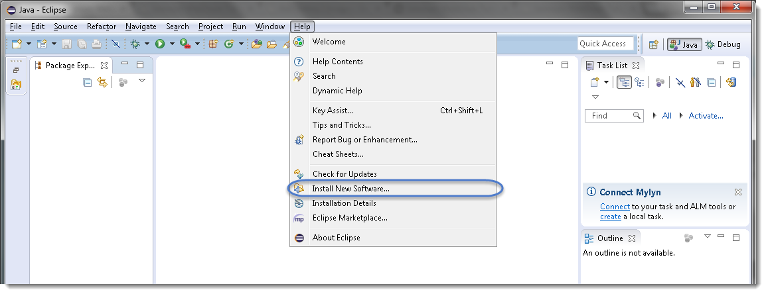
2) You will see a dialog window, click “Add” button.
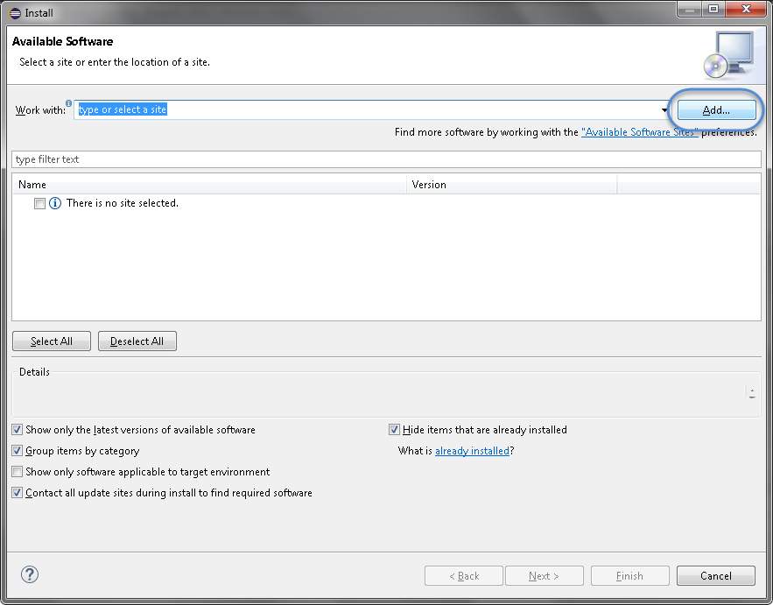

3) Type name as you wish, let’s take “Cucumber” and type “http://cucumber.github.com/cucumber-eclipse/update-site” as location. Click OK.
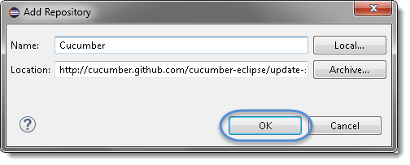
4) You come back to the previous window but this time you must see Cucumber Eclipse Plugin option in the available software list. Just Check the box and press “Next” button.
